Federalism

Finding the Constitution: A road map to our rights and responsibilities as citizens of the United States.

Welcome to Episode One of Constitution USA. In this episode, you will explore the delicate balance of federalism. Use this guide to help you pull key ideas from the video and help you build your understanding of, or “road map” to, the Constitution in your life. The questions will help guide you along the way but feel free to pause the video and re-watch when needed. Good luck and happy travels!

Birthplace of Federalism in the United States

Let’s head to the birthplace of federalism. Our trip takes us to which city in 1787? Here, the Framers of the Constitution gathered to try and build a strong new government. Below is a diagram of federalism. Label the two main components of our system and the roles of each.

How did the framers ensure a delicate balance between state and federal power? Not sure yet? Keep thinking—and here’s a hint: pay attention to the Commerce and Supremacy clauses that are coming up!
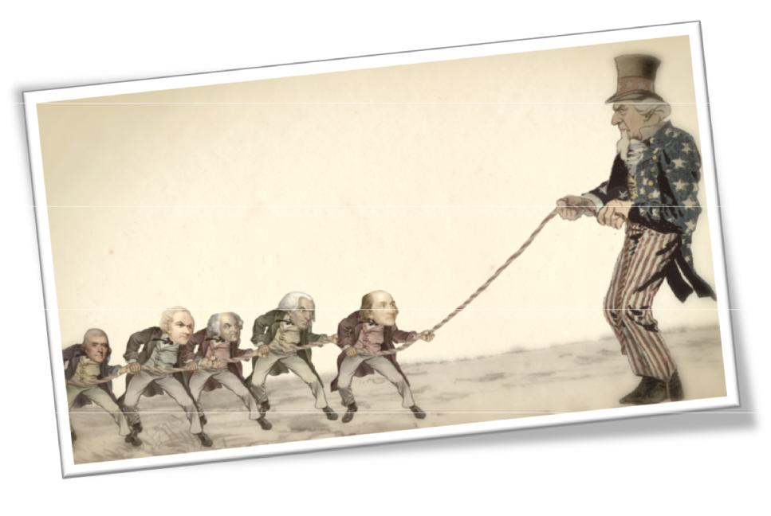

Episode 1 | High School Student Guide Student Handout Page 1

at the title of the videos in Episode 1 and follow along. Link Again
Constitutional Battleground States!
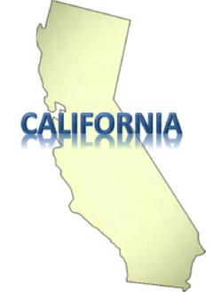
The Harborside Company in California can be seen as a respected business. In what realm is

Harborside an unlawful business (pre-11/2016)? How are the state and federal laws at odds?

Stop and Think Question: What are some examples from history that show how state and federal laws have found a balance?

The Big Bang Theory…The United States Constitution

Why does Akhil Reed Amar consider the writing of the Constitution the “hinge of history?”

List some characteristics of our national government before and after the Constitution:

Before 1787 After 1787

Articles of Confederation Government under the Constitution

What was the real catalyst to drive the states to unite?

Episode 1 | High School Student Guide Student Handout Page 2

Philadelphia and the Constitutional Convention

Why did the delegates call the Convention? What was the danger looming for Americans at that time? List some of the symptoms that show our country was not doing so well.

Who are the main players who pushed for the Convention and who is the person who had the plan for a new government?

What was the goal of the Convention?

What were some of the issues the delegates found with creating a strong central government?

Why did they eventually decide to build a strong central government?

Stop and Think Question: What is the Commerce Clause and what does it really say?

Stop and Think Question: What is the Supremacy Clause and what does it really say?

What could this new government do?

What can the | What can the
state | federal
government do? | government do?

Does this balance the power work or does it cause more issues? Why is such a balance necessary?

Episode 1 | High School Student Guide Student Handout Page 3

Slavery and Civil War-the big midterm test of the Constitution

Stop and Think Question: In 1861, was secession constitutional?

Stop and Think Question: What aspect of freedom do you think is essential to liberty?

Power Struggle: Tug of War
Why do we give power to the states at all? What is the reasoning behind state power? Do you agree with Gary?

Do you agree with the idea that states are “laboratories of democracy?” List some examples of when good ideas have risen up from the states. Can you think of some bad ideas that came from the states?

Help Wanted: Looking for a Federal Government to Secure the Union
Why did the federal government build the Hoover Dam? How did building the Hoover

Dam support the posterity of the Union?

What was the Great Depression? How many people were not working?

Stop and Think Question: Find the percentage of people not working today and compare it with the Great Depression.

What was the New Deal? What did it do? List some of the recovery projects.

Why do some people think the New Deal had negative outcomes?

Episode 1 | High School Student Guide Student Handout Page 4

Separate is NOT Equal!
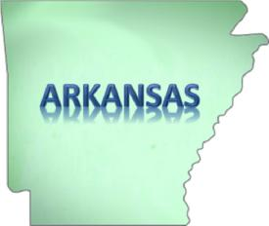
What federal body ruled that segregation in public education was illegal?

How did the state government push back against that decision?

What power (literally) does the president have?

Stop and Think Question: Why did the Army walk the kids up the front steps?

Commerce Clause and the Case of Feeding One’s Cows
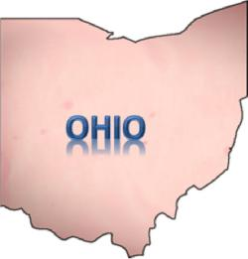
Stop and Think Question: Imagine you are hearing the case of Wickard v. Filburn.

Where do you fall on the case? What is your argument and why?

Write a conclusion on your decision as if you are the judge.

What is your opinion on the issues below—who should have the final word, the state governments or the federal government? Discuss with your group why you believe this.

ISSUES: | STATE | FEDERAL
Marijuana
Guns
Toilets (Energy conservation)
Coal Plants for Energy (Air Quality)
Wheat Farmers

Stop and Think Question: Have we struck the proper balance between the federal government protecting our rights and making laws effectively, or has the government overstepped its bounds?

Episode 1 | High School Student Guide Student Handout Page 5

